Technical Study



ECO STREETS



|  |  |
| --- | --- |
| Name | ID |
| Anas Hamed Mohamed | 4989 |
| Ibrahim Mostafa | 4715 |
| Islam Mustafa | 4595 |
| Mohannad Mahmoud | 5123 |
| Omar Ashraf | 4738 |
| Omar khattab | 5247 |
| Wadie Bishoy | 5074 |
| Karim Raafat Abdelmalek | 2465 |

DECEMBER 11, 2019

FEASIBILITY STUDY Alexandria, Egypt

Contents

INTRODUCTION ....................................................................................................................................................3

Charging infrastructure: .......................................................................................................................................3

Types of charging: ................................................................................................................................................5

Standards: to ensure clarity and high standards of Quality ............................................................................................................5

Overall implementation requirements ................................................................................................................6

* TECHNICAL REQUIREMENTS: ....................................................................................................................6
* POLICIES NEEDED: ....................................................................................................................................6

Detailed implementation requirements ..............................................................................................................8

* Materials input: ........................................................................................................................................8
* Spare parts:...............................................................................................................................................9
* Location analysis: ................................................................................................................................... 11

**Number of charging stations needed with estimate cost :** ........................................................................................ 12

**Positioning of the charging station:** ................................................................................................................. 13

* Resources needed: ................................................................................................................................ 13

**Electricity:** ......................................................................................................................................................... 13

**Labor:** ................................................................................................................................................................ 13

Conclusion: ........................................................................................................................................................ 14

*References* ......................................................................................................................................................... 15

INTRODUCTION

With the electric vehicle (EV) market becoming more significant specially in Europe over the past years, also the need for charging points is steadily increasing. Infrastructure and demand for EV’s have a “chicken and egg” like relationship as the more vehicles that are on the road, the more demand there is for charging stations, but the amount of charging stations deployed can also hinder the adoption of EV’s. With the EV market becoming more relevant, also the number of charging points has been steadily increasing, and according to association and media reports, there should be about 220,000 chargers by 2020 in western and northern Europe. So our main concern is to implement a sufficient number of charging points over all Egypt to support the electrical cars that our company import.

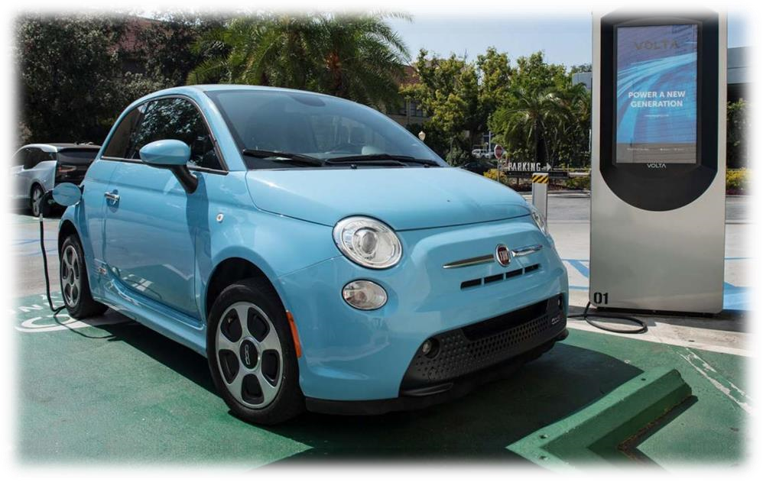

*Figure 1 Example of Charging point and how a vehicle will connect to it*

Charging infrastructure

Developing charging infrastructure requires major investments, and currently there are limited business models for private investment. Governments usually incentivize the installation of charging stations either at residential or public access locations.

The support for the development of charging infrastructure can be first based on ambitious EVs targets and then focused on specific funding for implementation projects. In addition, the need to understand how to best charge, aggregate and control the EV load on the grid is a fundamental and ongoing issue. This would impact important decisions in the development of charging

infrastructure – such as where to best place the charging points, which technology to use and how to combine slow smart chargers with fast chargers, to best meet consumer’s immediate needs.

In the UK, the Office of Low Emission Vehicles provides grant schemes to cover part of the cost associated with installing EV charging infrastructure. The Electric Vehicle Home charge Scheme provides residential customers grants that can cover up to 75% of the total procurement and installation costs.

Types of charging:

A look into the current operating practice reveals four different wired charging modes based on system standard DIN EN 61851-1, referred to as charging modes 1, 2, 3 and 4.

* Mode 1: as charging with a maximum of 16 A using single-phase socket outlets with earthing contact (in most European countries Schuko-socket) or three-phase industrial sockets (e.g. CEE socket). Mode 1 is typically used to charge small electric vehicles such as e-bikes, emotorcycles or e-scooters. In this mode a RCD (residual current device) is stringently required.

* Mode 2: describes single or three-phase AC charging with double current up to 32 A, also with household or industrial sockets. The main difference compared to mode 1 is that mode 2 uses a special charging cable with an integrated control and protective device. The IC-CPD (In-Cable Control and Protection Device) protects the user from an electrical shock caused by insulation defects if he has connected his vehicle to a power outlet that is not intended for charging.

* Mode 3: covers permanently installed charging stations with a charging cable and specially designed vehicle connections of type 1 and 2. The system includes built-in safety functions, such as a residual current device (RCD). The Equipment is deployed in practice to provide a quick charge with a single or three-phase alternating current of up to 32 A for all commonly used electric vehicles.

* mode 4: In contrast to charging mode 3, it charges vehicle batteries with up to 400 A DC. For this purpose, the charger is integrated into the station. The other structural features are similar to mode 3: Permanently installed charging station with fixed charging cable, lockable plug-in connections (Combo 2 or CHAdeMO) as well as protective functions within the charging station.

Standards: to ensure clarity and high standards of Quality

In general, for electrical planning, connections with power ratings above 2 kW have their own circuit. In assessments of single-phase charging stations, the diversity factor is 1. It should also be noted that socket outlets with earthing contact for household purposes use can only be used for short periods with a maximum current of 16 A. If continuous power up to 3.7 kW is required, socket outlets with suitable protections are used (e.g. CEE 16/3). The design of the supply cable must also comply with HD 60364-5-52.

This also includes temperature evaluation after one hour of continuous operation. A maximum temperature increase of 45 Kelvin is tolerable. Possible fire loads can be easily identified using the latest technology.

For these purposes Fluke Corporation (which we will try to implement the same technology from) has developed the new PTi120 thermal imaging camera. Its values can then be easily evaluated and assigned in conjunction with the new Fluke Connect asset tagging software.

OVERALL IMPLEMENTATION REQUIREMENTS:

* TECHNICAL REQUIREMENTS:

**Hardware:**

* Widespread adoption of EVs.
* Public and private charging infrastructure – smart charging points.
* Smart meters – required for supplying interval values for net consumption and net production.

**Software:**

* Smart charging services such as energy and power flow management systems that allow for optimal EV charging, ICT systems, intelligent charging infrastructure or advanced algorithms for local integration with distributed energy sources.

**ICT structure and development of communication protocols:**

* Agree and develop common interoperable standards (both at physical and ICT layers) as well as clear definitions and roles for actors and smart charging.
* Develop a uniform solution for the method of communication between charge points and the central power system, regardless of the vendor.

* POLICIES NEEDED:

**D Stable, supportive policies for e-mobility and smart charging.**

**Strategic policies could include:**

* Prioritization of demonstration and commercialization: Increased co-operation between public and private actors could enable the roll-out of large-scale demonstration and pilot projects.
* Win-win synergies and exchanges between the electricity, automotive and manufacturing sectors: the electricity industry should increasingly engage with e-mobility stakeholders in raising awareness and developing best practices with a focus on customer opportunities.

DETAILED IMPLEMENTATION REQUIREMENTS:

* Materials input:

**Charge stations incorporate several assemblies and controllers:**

* The power electronics assembly is the guts of a charge station. Functionally, it supplies the power to the EV’s onboard battery charger. Physically, it’s made up of wires, capacitors, transformers and other electronic parts.

* The charge controller serves as the “street smarts” of the charge station. It oversees basic charge functions, like turning a charger on/off, the metering of power usage and the storing of key bits of real-time and event data.

* The network controller provides the brains of the charge station. It enables the station to communicate with its network (via an on-board telecommunications device) so that managers can monitor it and review historical event data. It also controls user access to a charging station through a series of white (authorized) or black (unauthorized) lists.

* The charge station cable and connector plug into the target electric vehicle. These components provide the conduit for a charge to be delivered.

**Classification of electric charging station components:**

* **Physical components**, such as internal electronics, controllers, cord, EV-compatible plug and telecommunications devices to share data and enable network connections.

* **Software** applications to manage the charging, billing, driver access, and administration of an electric charging station program.

* **On-going service** to maintain physical and software components as well as provide customer service to both electric charging station owners and their driver constituents.

Spare parts:

1. **4 S A E J 1772 standard – A C charging**

Strictly speaking, Level 1 charging does not require a special charging station. It uses a Level 1 charging cable, which looks like a large laptop power pack cable and plugs into a standard 120-V outlet (CSA 5-15R). If that outlet is dedicated to EV charging, it must be supplied by a 20-A branch circuit (see Section 86 of the Code). Level 2 charging requires a fixed charging station supplied by a dedicated 208-V or 240-V branch circuit.

All electric vehicles sold in North America are equipped with a J1772 charging socket, except Teslas, which require an adaptor. The standard also describes Level 3 AC charging, but no compliant on-board chargers or charging stations are currently available on the market. At these power levels – up to 96 kW – automakers prefer to opt for an external DC charger connected directly to the EV battery.

1. **Operation of a J1772 charging station**

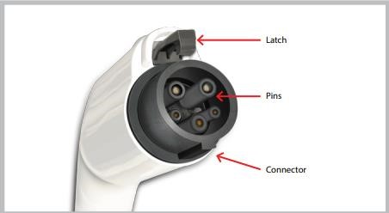When the charging connector (see Figure 3) is in its holster on the station, both it and the cable are completely de-energized and cannot be energized. When it is inserted into the EV socket, the connection is detected by the charging station, which communicates its maximum current to the EV. The EV sends a response signal indicating that it is ready for charging. After this handshake, the connector and the cable are energized and charging begins. Charging is managed by the on-board charger.

*Figure 3 Detail of J1772 connector*

LOCATION ANALYSIS:

When it comes to refueling a car, drivers of gas- and diesel-powered vehicles have it easy. They roll up to any one of the many gas stations available in different places around all Egypt, pump in liquid fuel in a matter of minutes, and pay either in cash or with a credit card. Unfortunately, it’s a little more complicated with public charging for electric vehicles. **Although** we have to mention that almost all EV charging takes place at home, which usually requires about 30 seconds to plug in each night.

So, from our main goals to is to provide these chargers through our company’s different selling partners all over Egypt, which we will begin to produce in phase 2 of our company.

However, the main concern now is to choose the most suitable locations in Egypt to implement the charging stations.

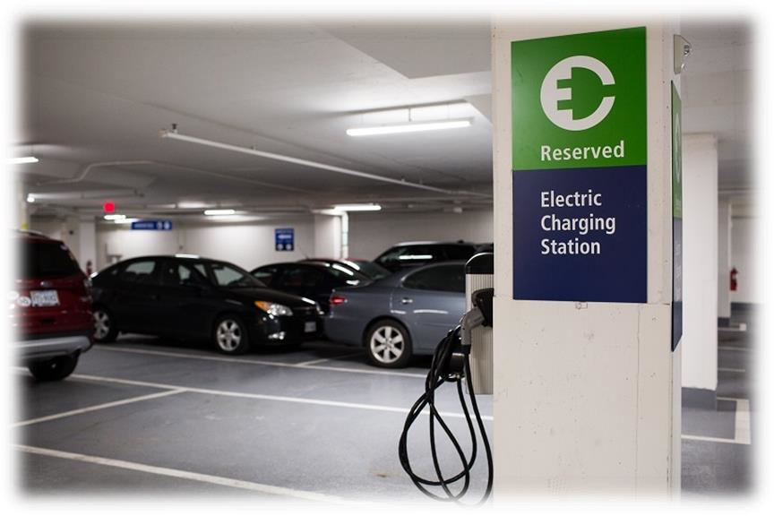

*Figure 6 Example of an electric charging station in a car park*

There’s a lot of science — or should be, at least — behind where, exactly, to put a rapidly growing number of electric-vehicle charging stations.

Automakers, electric utility companies, local and state governments and other parties are embarked on a charging-station building binge, ahead of a hoped-for increase in EV adoption.

But historically, they don’t always end up in the best places, according to San Francisco-based Streetlight Data, a company that tracks and analyzes traffic patterns, road use and much more, employing data from people’s mobile devices — primarily phones, as well as data from Internet-connected cars.

**Number of charging stations needed with estimate cost :**

Numerous studies have shown that consumers steer clear of EVs because they worry about the lack of charging stations. Studies also show that consumers are more likely to buy an electric car when they see stations around town. While fears about range anxiety are largely unfounded–even the cheapest EVs sport enough range to serve nearly all of a driver’s needs– the paucity of charging stations is a real concern on longer trips, and it is deterring consumers from going all-electric.

and – According to homeadvisor.com – the electric car charging station will cost around $436 - $984 , according to the location and the method of charging used.

So, our goal is to implement as many charging stations as we can all over Egypt ( according to the investment given in the economical & financial feasibility study ) , with at least :

* 1 charging station in each governorate
* 1 charging station in each main high way

(ex: Cairo/Alexandria Agriculture road - Cairo/Alexandria Desert road - Cairo/Red Sea High way )

* 3 charging stations in the capital or most crowded cities (ex: Cairo)
* 2 charging stations in the highly crowded cities (ex: Alexandria)

And the exact places/streets where the station will be implemented will be calculated using **Factor Rating** strategy for the options given in each territory , with **Factors** like :

* Land cost
* Traffic volume
* Size
* Layout

|  |  |  |
| --- | --- | --- |
| Location | Fixed cost | Size in m2 |
| Alexandria ( city center ) | 2500 EG | 140 |
| North Coast ( Sidi Kreer ) | 1100 EG | 510 |
| Matrouh | 3500 EG | 216 |
| Alexandria ( Mahatet El-raml ) | 4150 EG | 305 |

*Table 1 table of real suggested locations in Alexandria and behira governorate*

In conclusion, our target is to implement 40+ charging stations all over Egypt , with estimate cost of $40,000 in the installation phase.

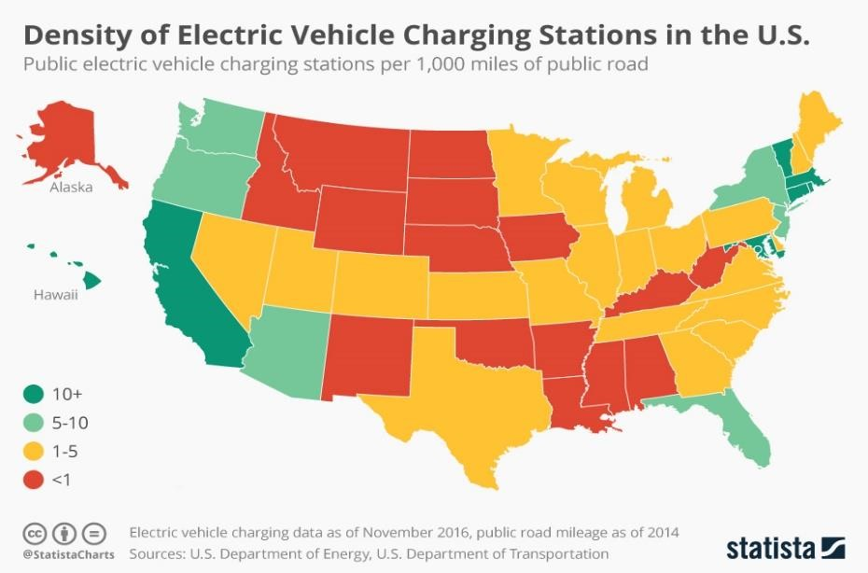

*Figure 7 Density of electric charging station in the U.S. in November 2016*

**Positioning of the charging station:**

The first things we have to consider are safety, accessibility and comfort of your guests.

In general it is suggested that the length of the electric line (the distance from the charging station to the next distribution box) is as short as possible. It is ideal to place the charging station halfway between two parking lots (with sufficient space in front) to allow charging of different types of electric vehicles.

If the charging station is not waterproof, it is necessary to provide adequate weather protection. To provide a more comfortable charging experience, you may also decide to light and protect the charging point.

• Resources needed:

**Electricity:**

Electricity is the main resource in the charging stations, and there are 2 ways to get electricity:

**1- Use common electricity resources:**

By making a contract with the government to buy electricity with a reduced price. (not our main source of energy , but important to increase efficiency) **2- Use renewable resources of electricity:**

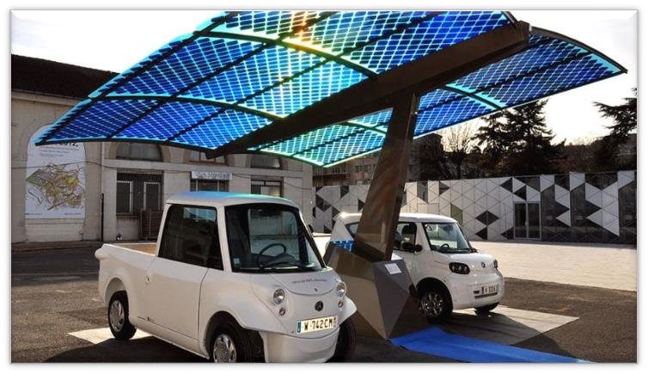To be truly respectful of the environment, and to our name **‘ ECO STREETS ‘** electric vehicles must be recharged with clean energy, that is coming from renewable sources (photovoltaic, wind or hydroelectric). For this the installation of a charging station must be accompanied by the choice of a 100% clean electricity supplier, or by the installation of a clean energy production plant.

And, one of the best solutions

(that we will use) is **solar panels**, with price In 2019, reaches $2.99/watt.

*Figure 8 A design for an EVCS using Solar panels*

**Labor:**

Human labor is needed in each station in form of:

* Manager for each station
* Working in the station for helping the guests
* Workers for maintenance

Conclusion:

We have found that the installation time for electric charging stations will not take much time and we will, therefore, start immediately after the legal approval throughout the order proposed in the marketing feasibility study.

Electric vehicles are here to stay but installing and commissioning the necessary charging stations requires electricians to have a suitable level of expertise. This applies to both the private and public sectors. Public charging stations especially demonstrate how important initial tests and regular periodic tests are. In the future, it will become increasingly important to be able to determine a fault in charging circuits safely and quickly using flexible measuring technology.

# References

1. [*https://www.gafi.gov.eg/English/MediaCenter/PublishingImages/A%20Companies%20Law%20with %20cover.pdf*](https://www.gafi.gov.eg/English/MediaCenter/PublishingImages/A%20Companies%20Law%20with%20cover.pdf)
2. [*https://www.gafi.gov.eg/Arabic/MediaCenter/News/Pages/laws.aspx*](https://www.gafi.gov.eg/Arabic/MediaCenter/News/Pages/laws.aspx)
3. [*https://www.gafi.gov.eg/Arabic/eServices/Pages/limitedcompanies.aspx*](https://www.gafi.gov.eg/Arabic/eServices/Pages/limitedcompanies.aspx)
4. *https://*www.wipo.int/edocs/lexdocs/laws/ar/eg/eg021ar.pdf
5. http://www.aun.edu.eg/fgaa/laws/79.pdf
6. <http://www.mof.gov.eg/mofgallerysource/arabic/insurance2010.pdf>
7. <http://www.gccegypt.org/Uploads/Laws/32145fddf454df.pdf>
8. <https://www.plugincars.com/ultimate-guide-electric-car-charging-networks-126530.html>
9. [https://www.forbes.com/sites/jimhenry/2019/10/31/putting-electric-vehicle-charging-stationswhere-people-will-actually-use-them/#1f9ab9bd22b8](https://www.forbes.com/sites/jimhenry/2019/10/31/putting-electric-vehicle-charging-stations-where-people-will-actually-use-them/#1f9ab9bd22b8)
10. <https://blog.arlingtontransportationpartners.com/properties-stand-out-with-ev-charging-stations>
11. <https://www.homeadvisor.com/cost/garages/install-an-electric-vehicle-charging-station>
12. <https://www.statista.com/chart/6586/electric-vehicle-charging-infrastructure/>
13. <https://ecobnb.com/blog/charging-stations-electric-vehicles-guide/>
14. https://news.energysage.com/how-much-does-the-average-solar-panel-installation-cost-in-the-u-s/